**MGBCCI Design**

**Design Specification**

Submitted by: The Face Shields Working Group (PMs: Evan Sevieri and Osman Ahsen)

Date: 04-JUN-20

Table of Contents

1. Purpose 3

2. Scope 3

3. Prototype Description/Background 3

3.1 Predicate Devices 3

3.2 Current Device 3

4. Electrical Specifications (If Applicable) 6

5. Mechanical Specifications 6

Additional Tools Needed: 6

6. Software Specifications (If Applicable) 6

7. System Specifications 6

8. Appendix 6

# Purpose

The purpose of this design specification is to provide a detailed set of performance characteristics which describe the output of the MGBCCI Design developed in conjunction with the MGB Center for COVID Innovation in Boston, Massachusetts.

# Scope

The scope of this document applies to the MGBCCI Design Version 01 developed in conjunction with the MGB Center for COVID Innovation in Boston, Massachusetts.

# Prototype Description/Background

## 3.1 Predicate Devices

There are many types of face shields used in clinical and non-clinical settings. The face shield mask currently used at MGH is the AlphaProTech Critical Cover® Coverall® Face Shield. This face shield’s “wrap around design provides great peripheral vision” as well as covering the face from non-hazardous liquid splash. The shield is 100% optically clear with a soft polyurethane foam headband that positions the device securely on the user (alphaprotech.com)

## 3.2 Current Device

The Lewis Lab Kirigami Face Shield is designed based on the input by working group leaders and the user criteria gathered by the working group. The face shield is based on similar designs that are in production, with the addition of an under-chin protection.

This design contains a under chin scoop which is folded from a flat design using two slots and clasps. This forms a curve at the bottom of the face shield as well as the main curvature around the user’s head. There is a similar fold and curvature on the top of the face shield to protect the users forehead and face from above. The face shield has a secondary piece that is slotted in to space the shield from the users face. The shield is fixed around the users head with a plastic band that slots in on the other side of the face shield.

**Device Components:**

|  |  |
| --- | --- |
| Component | Sub-Components |
| Face Shield | Flat packed visor/head strap |
| Head spacer | Flat packed head spacer |

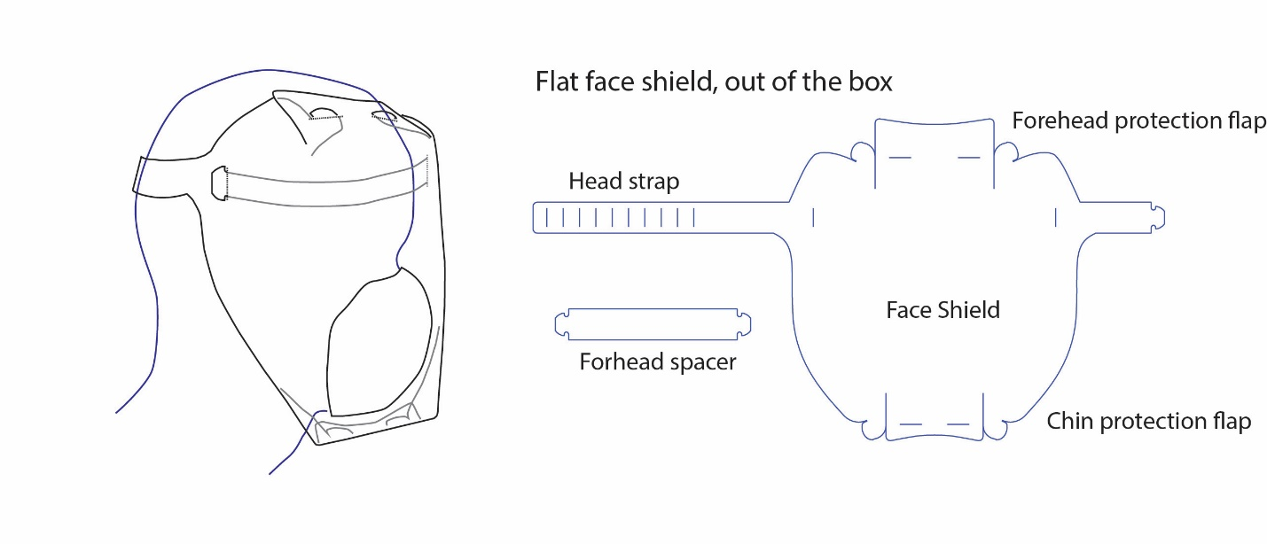

*Design A*

**How the designs meet the inputs:**

| **User Need** | **Design Input** | **Design Output** | **Lewis Lab Foam Design** |
| --- | --- | --- | --- |
|  | CRITICAL SAFETY INPUTS | *UNDERLINED ARE FDA REQUIRED* |  |
| Protection of user’s face from splashes and sprays | Protect eyes, nose, mouth from splashes, sprays, splatter, and boy fluids | Cover user’s entire face | Face shield dimensions are based on anthropomorphic head data to cover the user’s face from sides, front, and underneath |
| Protection of user’s face from splashes and sprays | Avoid potential splash to drip down from forehead | Have coverage above the forehead | Foam headpiece provides protection from above |
| General Safety and ease of use | The user should be able to easily don and doff the face shield | Familiar don and off adjustment mechanism and room to move over the head | Cord lock mechanism was tested by clinicians and was accepted as a don/doff mechanism |
| No interference with user’s vision | User should be able to see through the shield and be able to perform normal functions | Use optically clear material for visor | PET is optically clear |
| Can be worn comfortably for 8-12 hours | Biocompatible materials not causing user skin irritation | Use biocompatible materials (no latex) for body contacting features | Polyurethane is a common foam material used in body contacting features |
| Can be worn comfortably for 8-12 hours | Must be able to be worn comfortably for 8-12 hours | Comfortable head piece and strap and not heavy | Foam and head strap accepted by clinical feedback as comfortable for long shifts |
| Does not interfere with user’s normal functions | Compatible with stethoscope | Room around ears | Dimensions of face shield are based on anthropomorphic data and leaves room around ears for access |
| Does not interfere with user’s PPE | Compatible with use of glasses or goggles | Clearance between face and shield near eyes and nose | Foam forehead piece is 1.25” in height giving ample space for glasses and goggles |
| Does not limit user’s range of motion | Must be able to perform normal movement | Does not protrude excessively around sides or bottom | Based on anthropomorphic data and clinicala feedback the range of motion while wearing the face shield is acceptable |
| No assembly | Must require minimal to no assembly by user | Fully assembled from manufacturer | Manufacturers identified that can provide fully assembled face shields |
| Properly Labeled | Lists body contacting materials | Provide this info on label (ie: package insert label) | Information listed on package insert label |
| Properly Labeled | Includes labeling that describes the product as intended for either a single-user, single use, or for multiple uses by the same user | Provide this info on label (ie: package insert label) | Information listed on package insert label |
| Properly Labeled | Includes instructions for recommended cleaning and/or disinfection materials and processes if applicable | Provide this info on label (ie: package insert label) | Information listed on package insert label |
| Properly Labeled | The face shield does not contain any materials that will cause flammability, or the product meets Class I or Class II flammability requirement per 16 CFR 1610 (unless labeled with a recommendation against use in the presence of high intensity heat source or flammable gas) | Provide this info on label (ie: package insert label) | Information listed on package insert label |
| Properly Labeled | The product is not intended for any use that would create an undue risk in light of the public health emergency; for example, the labeling does not state that use of the authorized face shield alone will prevent infection from microbes or viruses, or that it is effective against radiation protection. | Provide this info on label (ie: package insert label) | Information listed on package insert label |
| Properly Labeled | The product is labeled accurately to describe the product as a face shield for medical purposes | Provide this info on label (ie: package insert label) | Information listed on package insert label |

# Electrical Specifications (If Applicable)

Not Applicable

# Mechanical Specifications

|  |  |  |
| --- | --- | --- |
| Component | Sub-Components | Material Details |
| Face Shield | Face shield visor/strap | Die-cut PET film 0.010” - 0.015” thick |
| Head spacer | Head Spacer | Die-cut PET film 0.010” - 0.015” thick |

# Software Specifications (If Applicable)

*Not Applicable.*

# System Specifications

The face shield is intended to be used on its own or with a respirator or surgical mask.

# Appendix

*[use the appendix to attach relevant CAD files, schematics, etc. DO NOT paste those documents into this document. Zip them into a compressed file and title them appendix a, appendix b, etc. and include in the dropbox along with this document]*